**PROJECT REPORT**

On

**Boomerang Books**

Submitted in partial fulfillment of the requirements

for the award of degree

**MASTER OF COMPUTER APPLICATIONS**

Of

**KLE TECHNOLOGICAL UNIVERSITY**

By

**Ms. Priyanka Rokhade** SRN: 01FM19MCA014

**Ms. Prarthana Charankar** SRN: 01FM19MCA024

**Ms. Kavya Goudar** SRN: 01FM19MCA025

**Under the guidance of**

|  |
| --- |
| Prof. Deepa M,  Prof. Amit V K,  Prof. P R Patil |



**DEPARTMENT OF MASTER OF COMPUTER APPLICATIONS**

**KLE TECHNOLOGICAL UNIVERSITY**

**Vidyanagar, Hubballi-580031 Karnataka.**

**June- 2021**

**DEPARTMENT OF MASTER OF COMPUTER APPLICATIONS**

**KLE TECHNOLOGICAL UNIVERSITY**



**CERTIFICATE**

This is to certify that the project work entitled

**“Boomerang Books”**

Submitted in partial fulfillment of the requirements

for the award of degree of

**Master of Computer Applications**

**Of**

**KLE Technological University, Hubballi, Karnataka**

is a result of the bonafide work carried out by

**Ms. Priyanka Rokhade** SRN: 01FM19MCA014

**Ms. Prarthana Charankar** SRN: 01FM19MCA024

**Ms. Kavya Goudar** SRN: 01FM19MCA025

**During the academic year 2020-2021**

|  |  |  |  |
| --- | --- | --- | --- |
| **Prof. Deepa M,**  **Prof. Amit V K,**  **Prof. P R Patil** | **Dr. P. R. Patil M.E, PhD** | | **Prof. N. H. Ayachit** |
| Project Guides,  MCA Dept | Head of Department,  Professor,  MCA Dept. | | Registrar,  KLE Technological University |
|  | ***Viva-Voce Examination*** | |  |
| Name of the Examiners |  | | Signature with Date |
| 1. _______________________________________ | |  | :____________________ |
| 1. _______________________________________ | |  | :____________________ |

**ACKNOWLEDGEMENT**

Every successful completion of any undertaking would be complete only after we remember and thank the almighty, the parents, the teachers, and the personalities, who directly or indirectly helped and guided during the execution of that work. The success of this work is equally attributed to all well-wishers who have encouraged and guided throughout the execution.

We express our deepest gratitude to **Prof. Deepa M, Prof. Amit V K and Prof. P R Patil** for their guidance and assistance throughout the project with great interest.

We avail this opportunity to express deepest gratitude to **Dr. P. R. Patil, HOD** for encouraging us with his valuable guidelines.

We are grateful to **Prof. N. H. Ayachit,** Registrar for his blessings and **KLE Technological University, Hubballi** that has given us a bright future. We would like to thank all the people for their guidance and valuable suggestions throughout the project.

We also thank all teaching and non-teaching staff members of the MCA department for their invaluable cooperation.

Finally, we would like to express our sincere thanks to our **Parents and Friends** for their enormous encouragement and all other who have extended their helping hands towards completion of our project.

**Ms. Priyanka Rokhade**

**Ms. Prarthana Charankar**

**Ms. Kavya Goudar**

**ABSTRACT**

*BOOMERANG BOOKS is a portal which allows user to buy and sell their old books. The proposed application runs in a web. User can buy the book using online payment system. The objective of this project is to create a portal which would allow product information to be updated securely using a website and will allow users to buy books from the user. The business-to-consumer aspect of electronic commerce (e-commerce) is the most visible business use of the World Wide Web. The primary goal of an e-commerce site is to sell books and services online. This project deals with developing an e-commerce website for online second hand book selling system. It provides the user with a list of different books available for purchase in the store. In order to facilitate online purchase a shopping cart is provided to the user.*

**BOOMERANG BOOKS**

**INDEX**

**TABLE OF CONTENTS**

1. **INTRODUCTION**………………………………………………………………..1-2

1.1 Project Overview

1.2 Objectives of the project

1.3 Literature Survey – The Current Situation

1.4 Problem Definition

1. **PROPOSED SYSTEM** ……………………………………………………………3

2.1 Description of Proposed System.

2.2 Description of Target Users

2.3 Advantages of Proposed System

2.4 Scope – The Context of the Work

1. **SOFTWARE REQUIREMENT SPECIFICATION**………………………….4-14

3.1 Overview of SRS

3.2 Requirement Specifications

3.2.1 Functional Requirements

3.2.2 Use case diagrams

3.2.3 Use Case descriptions using scenarios

3.2.4 Nonfunctional Requirements

3.2.4.1 Performance requirements

3.2.4.2 Safety requirements

3.2.4.3 Security Requirements

3.2.4.4 Usability

3.2.4.5 Any other

3.3 Software and Hardware requirement specifications

1. **SYSTEM DESIGN** …………………………………………………………….15-20

4.1 Architecture of the system

4.2 Level 0 DFD

4.3 Detailed DFD for the proposed system

4.4 ER Diagram

4.5 Class Diagram

4.6 Sequence Diagram

1. **IMPLEMENTATION** ………………………………………………………..21-23
   1. Proposed Methodology
   2. Description of Modules
      1. Admin
      2. User
2. **TESTING** …………………………………………………............................24-25

Test Plan and Test Cases

1. **RESULTS & DISCUSSIONS** …………………………………………………26-34

**CONCLUSION AND FUTURE SCOPE**

References/Bibliography

**Chapter 1 - INTRODUCTION**

* 1. **Project Overview**

The “BOOMERANG BOOKS” has been developed to override the problems prevailing in the practicing manual system. This system is designed for the particular need of the customers to carry out operations in a smooth and effective manner. The purpose of online shopping system is to automate the existing manual system to a full-fledged web application. Books are very essential for each and every one of us in order to increase our knowledge. The online second hand buying and selling portal idea is similar to the concept of shopping carts. The second-hand books can be purchased through the online mode and also sold. The updates of the books that are available can be mentioned through this web application.

* 1. **Objectives of the Project**

The sole purpose of the project is to design an online bookselling web application that simplifies the task of procuring items from the various sources and in return provides an invoice of successful transaction to the customer thereby ensuring consistency. Targeted Elements:

1. To reduce overhead.
2. To nurture individual privacy.
3. To acquire a global market reach.
4. To increase the auction.
5. To enhance accountability and productivity.
6. To reduce the activity cost.
7. To develop a sense of trust and belief amongst customers.
   1. **Literature Survey**

Introduction

In this globalization era where most people are exposed to the various type of new technology, there is still many people are sticking to the basic when it comes to reading. These people prefer reading a hard copy book rather than a technology based book like Kindle by Amazon where we can store many e-books inside it. It might be because of the screen of this technology book that emits light and it can hurt our eyes if we stare it for a long time that people do not prefer this way of reading. In OLX, many sellers wonder if there is a safe way of shipping [5]. The first step is agreeing on the shipping terms with the buyer: you can either agree for pre-payment or payment on delivery. The safest way to assure your sale is opting for pre-payment: once you have received the payment you can pack and send your item. However, the cost of new books nowadays is very expensive that it hinders people who love to read to buy many books that they want. So, people now are seeking other ways to get their wanted books for a cheaper price and one of the ways is to buy a second-hand book from other people that wanted to let go of their book.

Functions

“BOOMERANG BOOKS”, an online second hand book selling system is a customized website where we can easily buy second hand books at a cheaper price. This website also provides an option for the users where they can sell their second hand books to the admin and make profit for themselves.

Advantages

* Provide a way to buy cheaper books online.
* User will be able to make money for themselves by selling second hand books.
* It is easy to navigate and find books in various categories. It is also user friendly.

Limitations

* The books aren't always in the best condition.
* Lack of physical contact with the product.
* Books according to the choices of the customers are not always available.

Current Situation

In the current scenario the users or the customers follow an old fashioned method by visiting the shops to purchase the second hand books. There are very few shops which sell second hand books. It becomes very difficult for the customers to find those shops in their nearest locations and get their needed books at a cheaper price. This whole process consumes a lot of time. Also there are not many shops which accept the second hand books from the customers/users to sell. So thus to overcome this situation we have implemented an online second hand book selling website which is called “BOOMERANG BOOKS”. This is a website where customers/users can not only buy the second hand books of their choice at a cheaper price but also they can sell their second hand books and make money for themselves.

* 1. **Problem Definition**

To design and develop a web application for online second hand buying and selling book system “Boomerang Books” where the customers can buy second hand books from this website and also sell their second hand books to the admin.

**Chapter 2 - PROPOSED SYSTEM**

**2.1 Description of proposed System**

Second-hand book shopping has been a current trend in today’s stream. The purpose of this project is to give an Online Second-hand Bookshop System – “BOOMERANG BOOKS”. This website allows the users to buy the second hand books at the cheaper price. It also allows the customers to sell their books and earn money for themselves. Payment is made easier for the users by providing both cash on delivery and online payment modes. Once the user places the order , confirmation email is sent to the respective user.

**2.2 Description of the Target Users**

The Administrator will have additional functionalities when compared to the common user. He can add, delete and update the book details, book categories, member information and also confirm a placed order.

The Boomerang Books Website provides Customers with online shopping through a web browser. A customer can, create, sign in to his account, place items into a shopping cart and purchase using his credit card details. The website also provides an option to the customers where the user can sell their second hand books to the admin and also can give feedbacks.

**2.3 Advantages of the proposed system**

1. Provide a way to buy cheaper books online.
2. User will be able to make money for themselves by selling second hand books.
3. Easy to navigate and find books in various categories. It is also user friendly

**2.4 Scope – The context of the work**

“BOOMERANG BOOKS”, an online second hand book selling system is a customized website where we can easily buy second hand books at a cheaper price. This website also provides an option for the users where they can sell their second hand books to the admin and make profit for themselves. The website provides an online payment mode for the book purchases done. The site also provides a facility where the customer/user can track the location of the admin while selling their books to the admin.

**Chapter 3 - SOFTWARE REQUIREMENT SPECIFICATON**

**3.1 Overview of SRS**

**3.1.1 Scope**

BOOMERANG BOOKS Website is composed of two main components: a) Customer-side application and b) Administrator’s application. The development of this application is to facilitate the process of buying and selling of second hand books.

**3.1.2. Overall Description**

This section will give an overview of the whole application. The explanation of the application will be in its context to show how the application interacts with user and admin and introduce the basic functionality of it. It will also describe all the constraints and assumptions for the application.

**3.1.2.1 Product Perspective**

This product solves all the cons faced by traditional method of maintaining information related to books sold, books bought and availability of books, where to buy and sell, there is a personal visit to store. The product focuses on reducing the time complexity and making efficient use of man power. The application requires the following components: MySQL database, interface for transactions.

Buying and Selling Status

Confirmation

Buying, Selling and Payment Details

Users

Application

Login, Buying, Selling

Administrator Application

Fig.3.1.2.1

**3.1.2.2 Product Functions**

The following list offers a brief outline and description of the main features and functionalities of the “BOOMERANG BOOKS - Online Second Hand Book Selling” application. This application will consist of two parts: one application and web server for the administrator and another application for the user or customer. The customer/user will use the application to view books, buy books, and sell books. The administrator application will be used for managing the information of the books ordered, availability and details of users who wish to sell books using this website.

**3.1.2.3 User classes and classification**

The “BOOMERANG BOOKS - Online Second Hand Book Selling” application is meant to offer a buying and selling books that is faster, easier, and more convenient than manually maintaining the books that are bought and sold. Consequently, the application will have little or no learning curve, and the user interface will be as intuitive as possible. Thus, technical expertise and Application experience should not be an issue. Instead, any user with basic knowledge of E-commerce can make use of the application.

The administrators will have separate login application; they are responsible for managing the overall system so there is no wrong information within it. The administrator can manage the information about the books sold and bought along with payment location and availability of books. To place a order, customers would be required to first register and then sign-up to make successful orderings.

**3.1.2.4 Operating Environment**

The web application would work in any browser. For registration and signup process. The user and admin must have a valid and operating E-mail ID.

**3.1.2.5 Design Implementation Constraints**

The primary design constraint is the website based platform. Creating a user interface, which is both effective and easily navigable, will pose a difficult challenge. Other constraints such as limited memory and processing power are also worth considering.

**3.1.2.6 User Documentation**

In our application, we are going to design web application which will be explanatory. Every field will be provided with water marketing or place holder which indicates what data to be exactly added. To ensure that right data is accepted, every field is provided with data validation.

**3.1.2.7 Assumptions and Dependencies**

The application needs internet access. A web application is available for “Online Second Hand Book Selling” to store data (Book details) on (done by administrator) and retrieve data from (Ordering details) customers. The customers should register to view the books and buy it.

**3.2 Requirement Specification**

**User Interface**

There will be two user types – the application user and the application administrator – each of which will have its own corresponding interface.

**Application User**

The minimal requirements are that the customers should be able to interact with the system through the interface provided by Constraint layout or Relative layout. There will be a different command for each of the following actions:

* Look for user required books.
* Customer can order books online.
* Notification received from administrator

**Application Administrator**

The minimal requirements are that the administrator should have a separate application and in addition to that, additional commands will allow the administrator to:

* Check the status of orders received (shipped or unshipped).
* Alter the cost structure of the books
* View the location of the user who wants to sell books.
* Send appropriate notifications

**Hardware Interface:**

The minimum hardware requirements for this application are as follows:

* Processor Intel-Core I3 or above
* 8GB RAM
* 30 GB free space

**Software Interface:**

The development of the application requires the following software’s:

* Windows XP or above
* PyCharm
* SQLite3

**Communication Interface**

Every user will be provided with separate logins. Administrator and customer will be given with same web application with different features.

**System Features**

The main feature of the application is to provide the customers a smooth experience of buying second hand books and sell books if they wish.

The application contains the following core features:

* Register/Sign-up
* Sign-in
* User books ordering
* Confirmation of order
* User books selling
* Accept book requests for selling from users
* Payment details
* Tracking of admin location

|  |  |  |
| --- | --- | --- |
| **Class of use cases** | **Use cases** | **Description of use cases** |
| Use case related to register/sign up | Successful register | Can use the application. |
| Unsuccessful register | Application cannot be used. |
| Use case related to login | Successful login | Logins to the application. |
| Forgot password | Reset the password. |
| Use case related to ordering of books | Browsing | User can browse and select the required books and order for the same. |
| Ordering the books | After choosing the books, ordering can be continued. |
| Use case related to ordering process | Successful ordering | Administrator gets notified. |
| Unsuccessful ordering | Re-enter the details to order the books. |
| Use case related to administrative | Successful login | Can add, edit and delete the required details. |
| Unsuccessful login | Appropriate message will be displayed |
| Use case related to notification | Administrator receiving order notification | Admin will be notified once the user orders for the books. |
| Customer receiving the acknowledgement notification | Customer will receive the notification regarding order confirmation. |

**Register/Sign-up and Sign-in**

This feature requires the user to register himself into the system. The first page of the application will lead the user to the registering form.

**Description and Priority**

When the user opens the application for the first time, he is required to register and then log in. The main screen contains the option to register, wherein he is required to enter his /her email-id, set a password, and create a profile within the application. After registering, customer can alter the information such as his/her name, email-id, password, phone number.

After registering, the user can successfully sign into the application. Registration is of top most priority and each individual customer is required to enter or register to use the application. Without registering, the administrator cannot process any operations.

**Stimulus/Response Sequences**

Case 1: Successful registration of new customer/user

The user is required to enter his email id with valid domain (Gmail), create and enter a password for his profile. The user will be required to enter his password twice for consistency.

After registering, the user will get an online password with user-id.

Case 2: Unsuccessful registration

If the password entered by the user does not match (while entering twice), he/she will be prompted to re-enter the password.

If the mailing domain is invalid, the user needs to provide a valid mailing domain, which in this case is gmail.com. Else the registration would be incomplete.

Case 3: Successful sign in

If the user enters the correct email id and password, that is, registered in the MySql database.

Case 4: Unsuccessful sign in

If the user does not enter correct details, then, a toast message saying “Login Unsuccessful”, will be provided.

In case the user cannot provide the correct password or has forgotten it, he/she has the option to rest the password. This facility is at the login page itself, where the user has to provide the registered Email id.

**3.2.1 Functional Requirements**

**A) Login Module**

Input – User can login using the credentials username and password.

Processing – In the processing it checks for the valid username and password entered to the data

stored in the database.

Error Handling – If the input credentials are invalid appropriate message will be displayed and

the user has to login again with the valid data.

Output – Once the login is successful, user will be redirected to the home page.

**B) Ordering Books**

Input – User can order the books from their respective carts.

Processing – The ordered placed by the user will be stored in their respective user’s data.

Error handling – User cannot order the books if their cart is empty.

Output – Order is confirmed through the email and user can view the order status.

**C) Administrative**

Input - Administrative involves managing of the ordering or requests placed by the customers.

Also, adding and updating the orderings in the database.

Processing – Admin processes the orders from the user and also the user requests to sell their

books.

Error handling – Invalid credentials will not take him to the admin panel.

Output – User is notified with the respective message according to the user activity.

**D) Sell Books**

Input **–** User will provide the details of their second hand books to be sold.

Processing – Admin is notified with the user’s request to sell their books and accepts or rejects

the requests based on the details provided.

Error Handling – If user tries to submit without entering the details the request will not be stored

and error message will be displayed.

Output – Users can view the books sold by them.

**3.2.2 Use Case Diagrams**

Fig 3.2.2 represents the use case diagram for customer and admin modules.

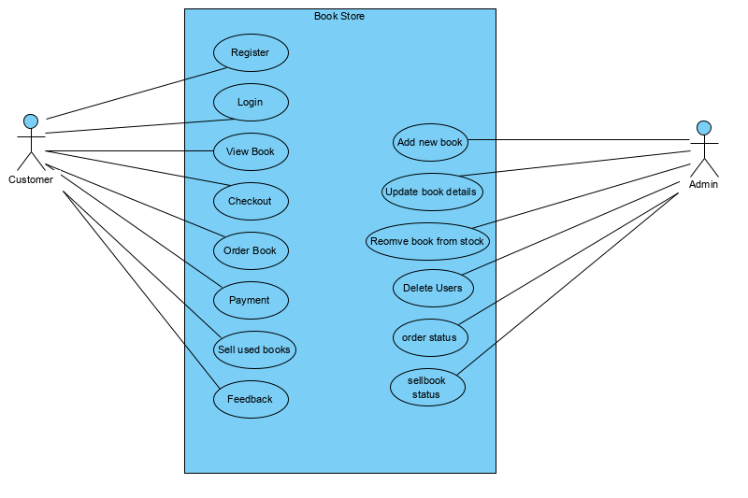

Fig.3.2.2 Use Case diagram

**3.2.3 Use Case Descriptions Using Scenarios**

**Customer**

* Customer initially visits the website and registers himself as he is a new user.

While registering the user has to fill in all the details asked accurately which has to be a valid detail.

* Once the user registers himself in the website he becomes a registered user. Now the user can login into the website using appropriate credentials. While logging-in if the user forgets their password or wish to change the password

They can get it done by clicking on forgot password or change password respectively as per the requirement. This process is validated using email. The user will receive an email to their respected accounts to do the same.

* Once he logins to the website the user can view the product catalog of the available second hand books. The user can view all the related product details like book name, price, author and other book details.
* As he looks out to the book details and if the user wants to buy the book, he/she can add that product to the cart. As the user click on add to cart button he is provided with increase and decrease buttons for the quantity of the products he would like to order.
* When he put all the products he want to buy to the cart along with their quantity as per the need he can click on the checkout menu to order the books.
* When clicked on checkout a form appears on the screen with prior filled details of the respective user who would like to order.
* In that form the user has to proceed ordering by choosing the payment modes. The website is provided with two payment modes COD and Online payment. The user has to choose the modes and can order the book. Once ordered the user can view their order status whether it is pending or delivered. The status will be ‘pending’ until the user receives the book and ‘delivered’ once the customer receives the book.
* The customer is also provided with an option to sell their second hand books in this website to the admin. The user has to click on ‘sell books’ options from the user menu. When clicked on that option a form appears on the screen. The user has to fill in all the details in the form and has to upload the pictures of the books he want to sell and send request to sell their book to admin by submitting the form.
* The admin gets request from the user and he checks for the condition of the book. The user can see their requested status as request ‘pending’ and request ‘accepted’. When the admin is satisfied with the condition of the books the user wants to sell the updates the status of the book request. The request status will be ‘pending; until the admin accepts the book the user want to sell and ‘accepted’ once the admin accepts the users request. Here the user can also track the location of the admin while selling their books.
* The customer is also provided with a feedback option in the menu where they can give their feedback of their purchase or any other suggestions. Also they can give ratings for the same.

**Admin**

* The admin logins using the admin credentials. Admin adds existing and new books to the stock.
* He can also add the users.
* The admin updates all the book details and book stocks if any.
* He can also remove the books from the stock.
* The admin is provided with an option where he can delete the users.
* When users requests for the book order the admin confirms the book orders.
* Also when the customer’s request for their second hand book to sell the admin checks for the condition of the book and the book details and then accepts the book request sent by the customer.

**3.2.4 Non-Functional Requirements**

**3.2.4.1 Performance Requirements**

To run the application, users will require browser with minimum configuration of

* Strong Internet connection.

**3.2.4.2 Safety Requirements**

“BOOMERANG BOOKS - Online Second Hand Book Selling” website will not affect any other applications installed on the user’s computer. It cannot cause any damage to the computer or its internal components.

**3.2.4.3 Security Requirements**

This application assumes that only the user will have access to his/her details regarding ordering and selling. With this being said, only a Google email address with password is required to verify the identity of the user upon opening the application. This application uses hash code in generation of user passwords. We have also implemented e-mail verification for forgot password and captcha for user registration.

**3.2.4.4 Software Quality Attributes**

The graphical user interface of “Online Second Hand Book Selling” application keeps usability as the first priority while designing. The application presented and organized in such a manner that is both visually appealing and easy for the user to navigate through the menu.

**3.2.4.5 Business Rules**

The service will be provided to the customer 24/7.

**3.3 Software and Hardware Requirement Specifications**

* + 1. **Hardware Requirements**
* Processor : Core i3 and above
* RAM : 8 GB
* Hard Disk Space : 30 GB
  + 1. **Software Requirements**
* Operating System: Windows XP or above.
* Front End: HTML5, CSS 3, Bootstrap and JavaScript.
* Back End: Django, SQLite3.
* Editor: PyCharm.

**Chapter 4 - SYSTEM DESIGN**

**4.1 Architectural Design**

An early stage of the system design process.

• Represents the link between specification and design processes.

• Often carried out in parallel with some specification activities.

• It involves identifying major system components and their communications.

Simple, informal block diagrams showing entities and relationships are the most frequently used method for documenting software architectures. Fig 4.1 represents the architecture design.

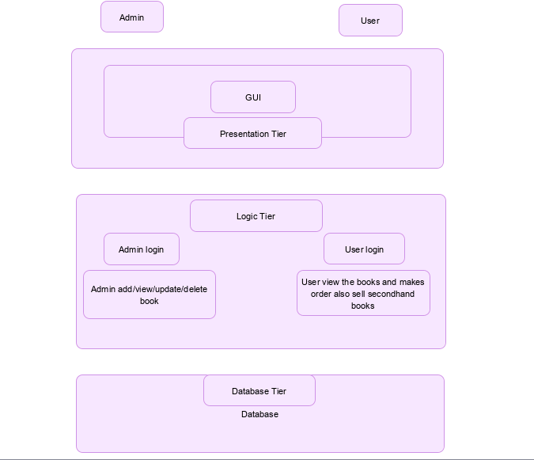

Fig 4.1 Architecture Diagram

**4.2 Level 0 DFD**

It is also known as a context diagram. It’s designed to be an abstraction view, showing the system as a single process with its relationship to external entities. It represents the entire system as a single bubble with input and output data indicated by incoming/outgoing arrows.

Fig 4.2 represents the level-0 DFD.

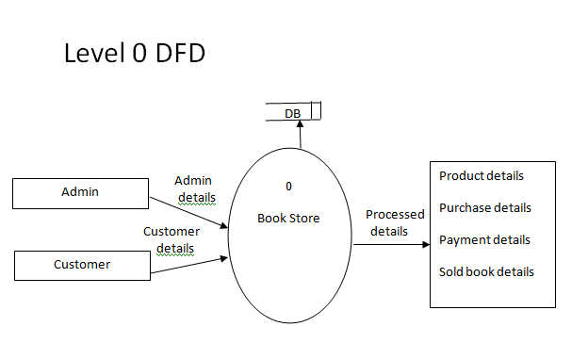

Fig 4.2 Level 0 DFD

**4.3 Detailed DFD of the proposed system**

Data flow diagrams are used to graphically represent the flow of data in a business information system. DFD describes the processes that are involved in a system to transfer data from the input to the file storage and reports generation. Data flow diagrams can be divided into logical and physical. Fig 4.3 represents detailed DFD of the proposed system.

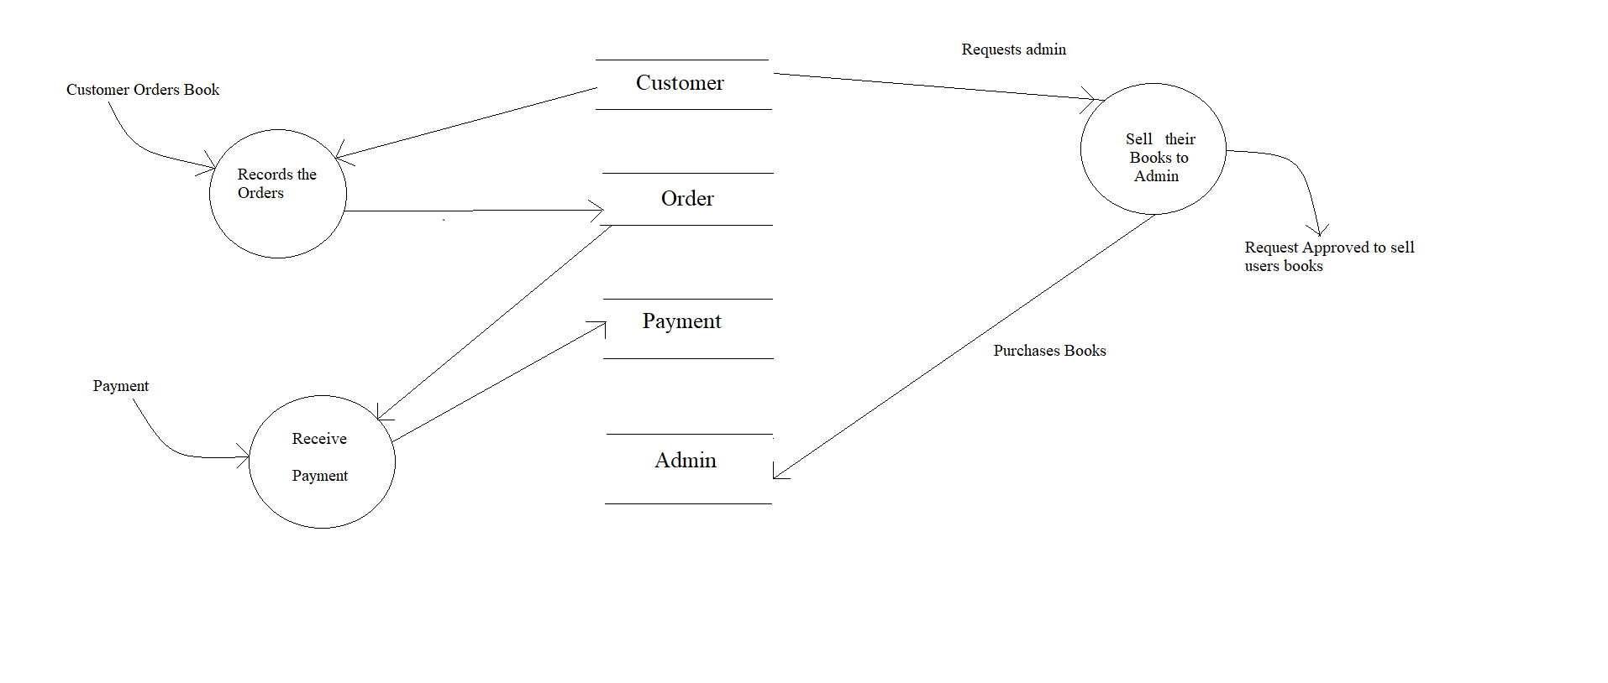Fig 4.3 Detailed DFD

**4.4 ER Diagram**

**ER Diagram** stands for Entity Relationship Diagram, also known as ERD is a diagram that displays the relationship of entity sets stored in a database. In other words, ER diagrams help to explain the logical structure of databases. ER diagrams are created based on three basic concepts: entities, attributes and relationships. Fig 4.4 represents detailed DFD of the proposed system.

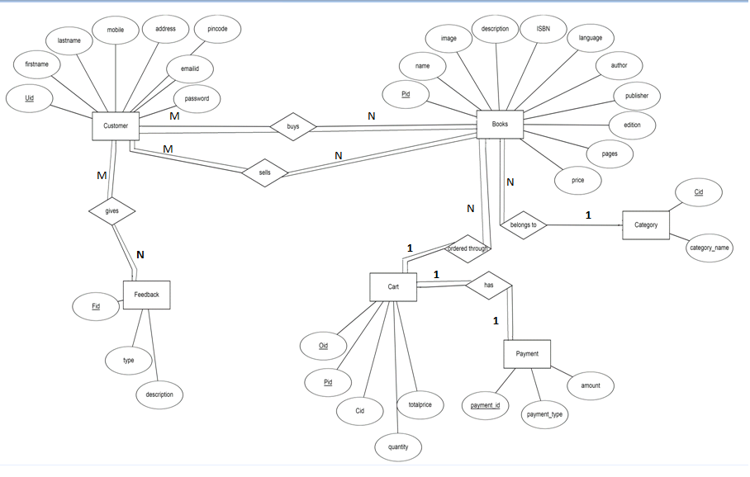

Fig 4.4 ER Diagram

**4.5 Class Diagram**

The classdiagram is the main building block of object-oriented modeling. It is used for general conceptual modeling of the structure of the application, and for detailed modeling, translating the models into programming code. Classdiagrams can also be used for data modeling. Fig 4.5 represents the class diagram.

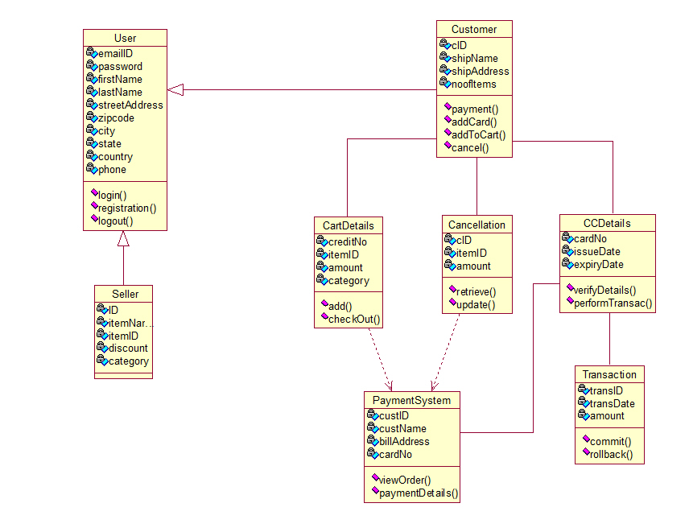

Fig 4.5 Class Diagram

**4.6 Sequence Diagram**

A sequencediagram is a type of interaction diagram because it describes how—and in what order—a group of objects works together. These diagrams are used by software developers and business professionals to understand requirements for a new system or to document an existing process. Fig 4.6 represents the class diagram.

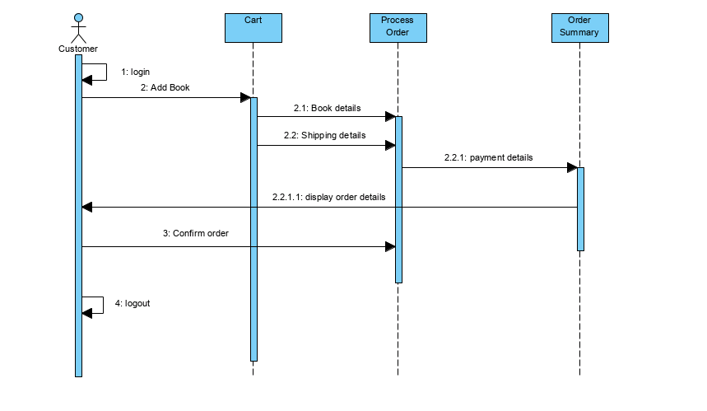

Fig 4.6 Sequence Diagram

**Chapter 5 - IMPLEMENTATION**

**5.1 Proposed Methodology**

In the current scenario the users or the customers follow an old fashioned method by visiting the shops to purchase the second hand books. There are very few shops which sell second hand books. It becomes very difficult for the customers to find those shops in their nearest locations and get their needed books at a cheaper price. This whole process consumes a lot of time. Also there are not many shops which accept the second hand books from the customers/users to sell. So thus to overcome this situation we have implemented an online second hand book selling website which is called “BOOMERANG BOOKS”. This is a website where customers/users can not only buy the second hand books of their choice at a cheaper price but also they can sell their second hand books and make money for themselves.

This website is developed on the basis of the python language using Django framework at the back-end. For the designing purpose it is implemented using HTML5, CSS3, Bootstrap and JavaScript at the front-end. For writing of the codes PyCharm Editor is used.

**Technologies used**

**HTML:** Hypertext Mark-up Language is the standard markup language for creating web pages and web applications. With Cascading Style Sheets (CSS) and JavaScript, it forms a triad of cornerstone technologies for the World Wide Web. With HTML constructs, images and other objects such as interactive forms may be embedded into the rendered page.

**CSS:** Cascading Style Sheets describes how HTML elements are to be displayed on screen, paper or in other media. CSS saves a lot of work. It can control the layout of multiple web pages all at once. CSS is a cornerstone technology of the World Wide Web, alongside HTML and JavaScript.

**JAVASCRIPT:** JavaScript often abbreviated as JS is a high level, interpreted programming language. JavaScript is one of the three core technologies of the World Wide Web. It enables interactive Web pages and thus is an essential part of web applications. The vast majority of websites use it and all the major web browsers have a dedicated JavaScript engine to execute it.

**Bootstrap:** Bootstrap is a free and open-source CSS framework directed at responsive, mobile-first front-end web development. It contains CSS- and (optionally) JavaScript-based design templates for typography, forms, buttons, navigation, and other interface components.Bootstrap is a framework to help you design websites faster and easier. It includes HTML and CSS based design templates for typography, forms, buttons, tables, navigation, modals, image carousels, etc.

**PYTHON:** Python is an interpreted, object-oriented, high-level programming language with dynamic semantics. Python’s simple, easy to learn syntax emphasizes readability and therefore reduces the cost of program maintenance. Python supports modules and packages, which encourages program modularity and code reuse.

**Django:** Django is a high-level Python web framework that enables rapid development of secure and maintainable websites. Built by experienced developers, Django takes care of much of the hassle of web development, so you can focus on writing your app without needing to reinvent the wheel.Django is the fastest growing, most popular framework out there right now. It is a huge community. There is a future at least 10 years out. No Django dev is becoming obsolete for at least a decade.

**SQLite3:** SQLite is a relational database management system (RDBMS) contained in a C library. In contrast to many other database management systems, SQLite is not a client server database engine. Rather, it is embedded into the end program. SQLite is a popular choice as embedded database software for local/client storage in application software such as web browsers. It is arguably the most widely deployed database engine, as it is used today by several widespread browsers, operating systems, and embedded systems (such as mobile phones), among others.

**5.2 Modules Description:**

**5.2.1 Admin**

1. **Manage Products**

Admin can add, update and delete books and book details. The admin will also manage requests from the users to sell the books.

1. **Manage Orders**

Admin can manage orders by accepting the book orders from the users. He can update the status of order as delivered once the user receives the book.

1. **Manage Book Requests**

Admin can accept the books requested by the users to sell. He checks for the conditions of the book and if interested he accepts the request. And if he is not satisfied with the condition of the book he will reject the request.

**5.2.2 User**

1. **View Books**

User can view the books available from the product catalog. In the product catalog user can view and select the books as per their requirements and categories.

1. **View book description**

User can view the book details like the book’s description ,author, name, category and its price.

1. **Add to Cart**

Add to Cart is a way to create a temporary list of items, which will keep track of the items until you leave our website. The user can add the books he wants to purchase to the cart. He can also increase and decrease the product quantity.

1. **Place order**

User can select the book and then place order. Admin will ship the order for respective users to their shipping address.

1. **My Order**

User will check the ordered books in my order section. All the ordered books details are stored here.

1. **Online payment**

Using Razor pay payment gateway user can make the payment using different modes like UPI, net-banking etc.

1. **Sell books**

Here the user requests the admin to sell his second hand book and make money for himself.

**Chapter 6 - TESTING**

Testing is process of executing a program with the intent of finding an error. A good test case is one that high probability of finding an as yet undiscovered error. A successful test is one that uncovers an as yet undiscovered error. Testing cannot show the absence of defect, it can only show that software errors are present.

**Test case:**

|  |  |  |  |  |  |  |  |
| --- | --- | --- | --- | --- | --- | --- | --- |
| Reference Id | Test  Case | Input | Expected  Output | Error  Handling | Actual  Output | Status | Reference |
| 1 | Username and Password | Valid Username and Password | It should display respective page. | Invalid credentials message is displayed.  . | Home page is displayed. | Passed | Fig 7.3  Login interface. |
| 2 | Username and Password | Invalid Username and Password | It should give appropriate error message saying “Invalid User” | Invalid credentials message is displayed. | Error message Displayed. | Passed | Fig 7.3  Login interface. |
| 3 | Mismatch password | Mismatch of password and confirm password. | It throws a message stating that “passwords do not match”. | Invalid password message is displayed | Message displayed successfully | Passed | Fig 7.2  Signup  interface |

|  |  |  |  |  |  |  |  |
| --- | --- | --- | --- | --- | --- | --- | --- |
| 4 | Text box | Leave all the text boxes blank | Prompt to fill the required details. | Fill in the  required inputs  – message is  Displayed. | Prompt to fill the required details. | Passed | Fig 7.2  Sign-up Interface. |
| 5 | Add products | Adding products to the cart. | Add product action is taken. | None. | Product added to the cart successfully. | Passed | Fig 7.4  Product Catalog Interface. |
| 6 | Remove  products | Removing products from the cart. | Remove product action is taken. | None. | Product removed from the cart successfully | Passed | Fig 7.5  Checkout Interface. |
| 7 | Payment | Online payment mode. | Payment processing action is taken. | Payment cannot be done if the user has not logged-in. | Email is sent to the respective customer. | Passed | Fig 7.7  Payment Interface. |

**Chapter 7 - SNAPSHOTS**

1. **Home Page**

This is the home page of the website “BOOMERANG BOOKS” consisting a menu bar as shown in fig 7.1

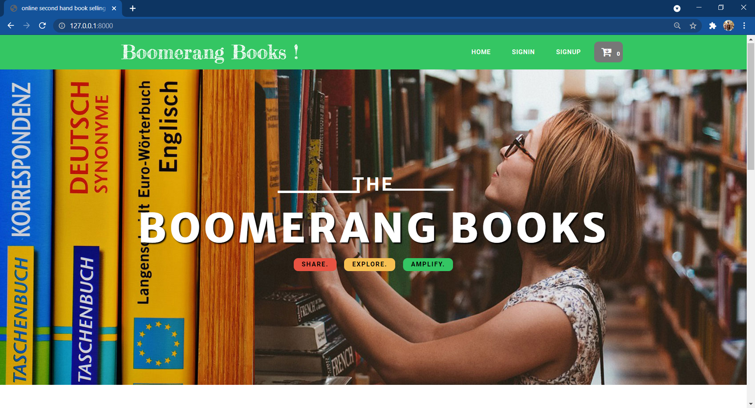

Fig 7.1 Home page

1. **Sign-Up Page**

This is the sign-up page of the website “BOOMERANG BOOKS” which consists of the following data fields to be filled to be the registered user of the website as shown in fig 7.2

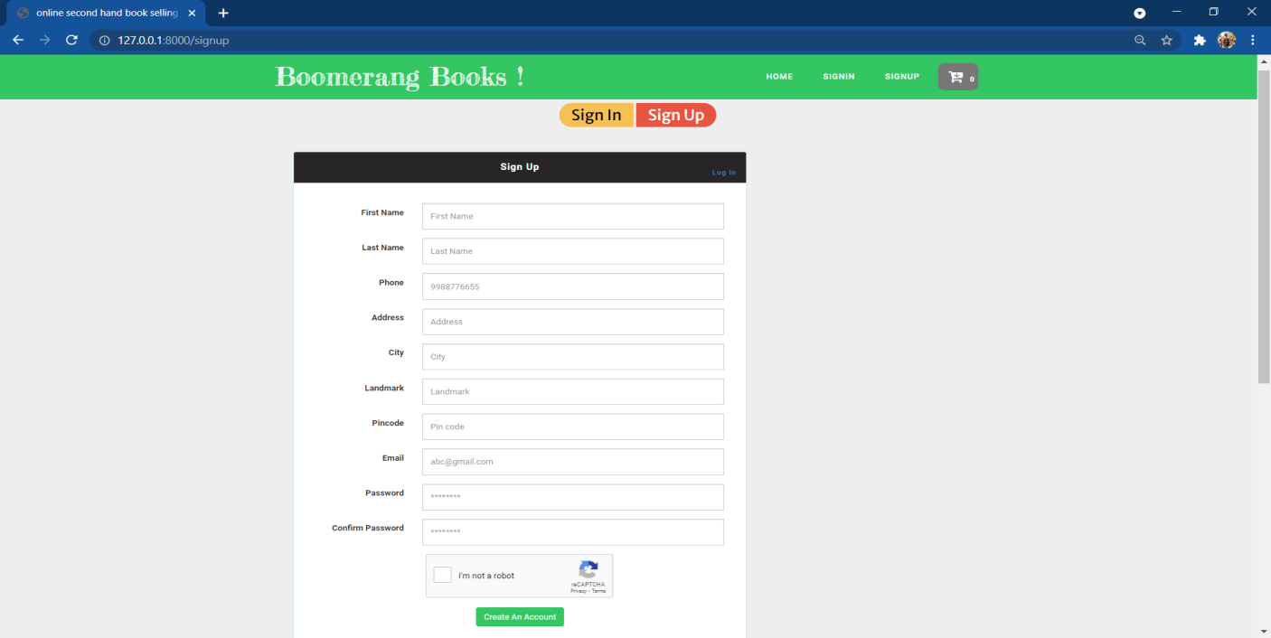

Fig 7.2 Signup page

1. **Login Page**

This is the log-in page of the website “BOOMERANG BOOKS” where the registered user/customer can login to the website by filling up the user credentials as shown in fig 7.3

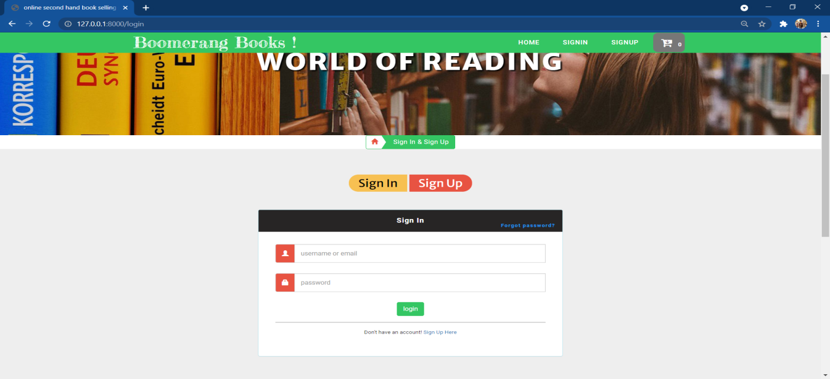

Fig 7.3 Login page

1. **Product Catalog Page**

This is the product catalog page of the website “BOOMERANG BOOKS” which consists of the all the products i.e. the second hand books available in the stocks along with their images and descriptions. Here the user can surf the products, add them to the cart for purchase. They can also surf particular category books which is provided in the category menu to the left of this page as shown in fig 7.4

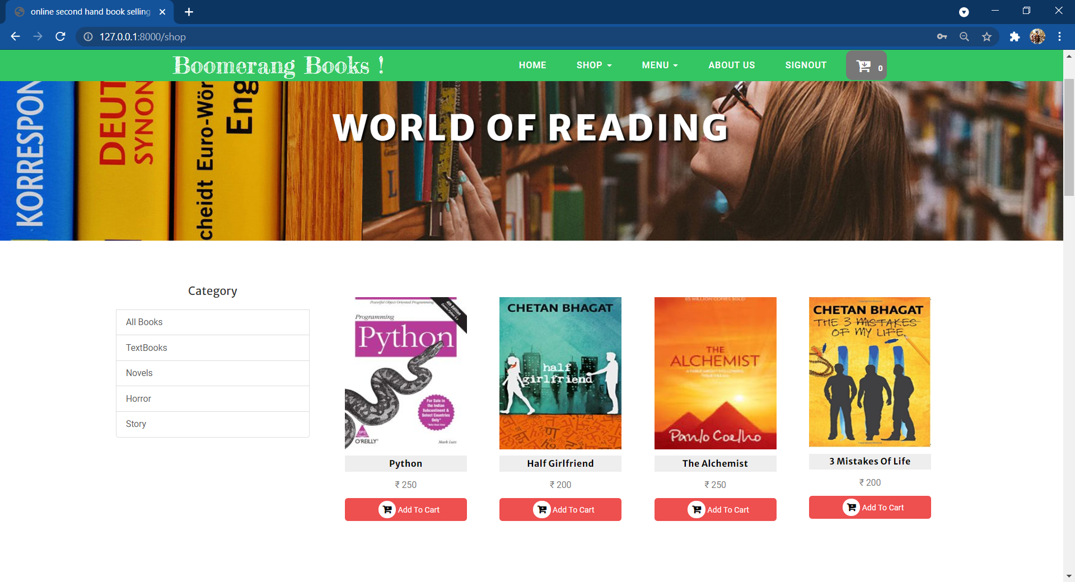

Fig 7.4 Product catalog page

1. **Check-out Page**

This is the check-out page of the website “BOOMERANG BOOKS” which consists of the books which were added to the cart by the users, the product details like the product name, its image, and quantity of the items added and the total amount of the products. Then the user can click on the Proceed to Checkout button to checkout as shown in fig 7.5

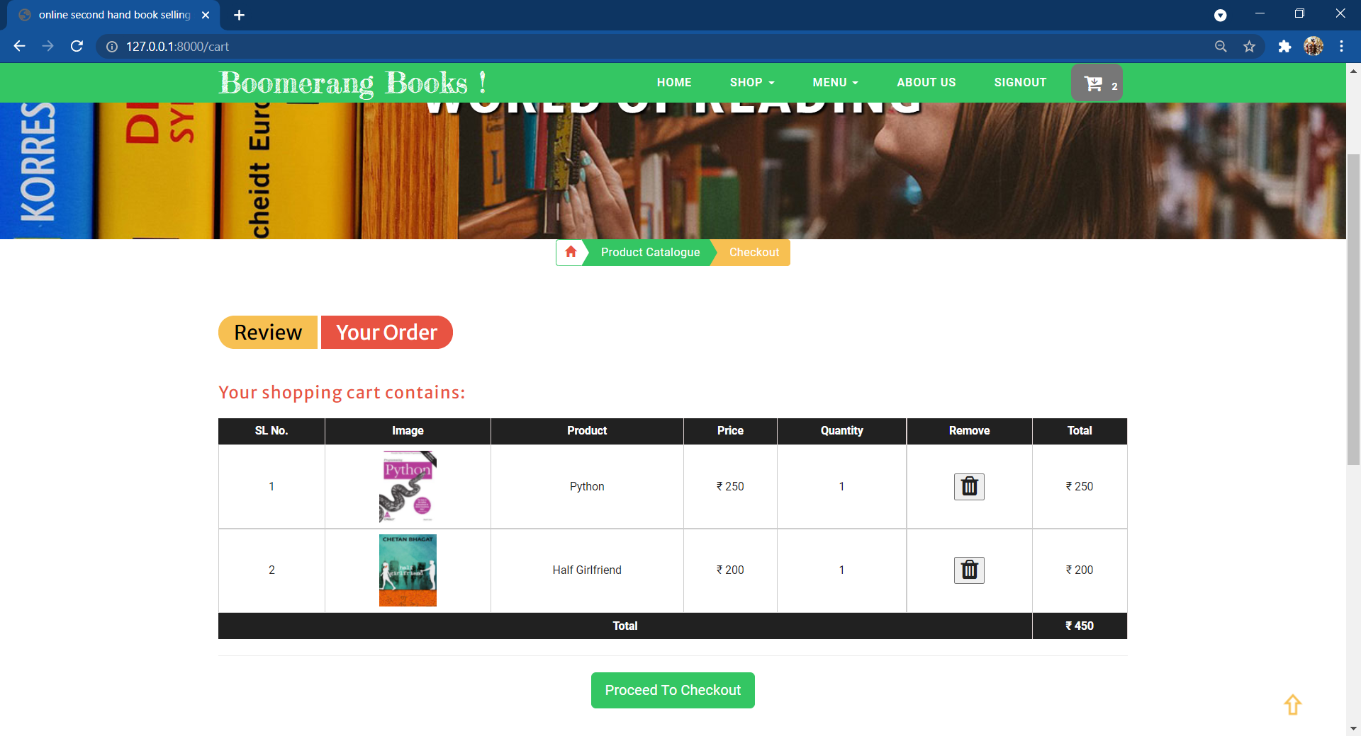

Fig 7.5 Check-out page

1. **Check-out Form**

This is the check-out form of the website “BOOMERANG BOOKS” which occurs when clicked on the Proceed to Checkout button. The Check-Out form consists of the following fields which consist of the particular user details which are auto filled priory. The user just has to select the payment mode and click on the checkout button to place the order as shown in fig 7.6

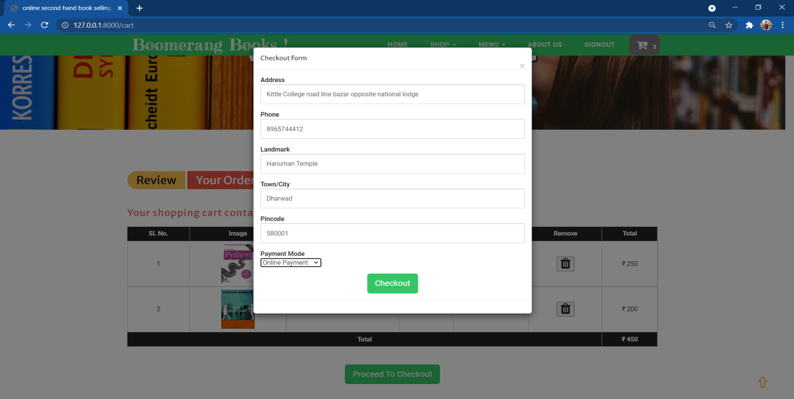

Fig 7.6 Check-out form

1. **Online Payment Page**

This is the online payment page of the website “BOOMERANG BOOKS” which occurs when the user choose the online payment mode instead of cash on delivery. Here the user can make his online payment for the order he places as shown in fig 7.7

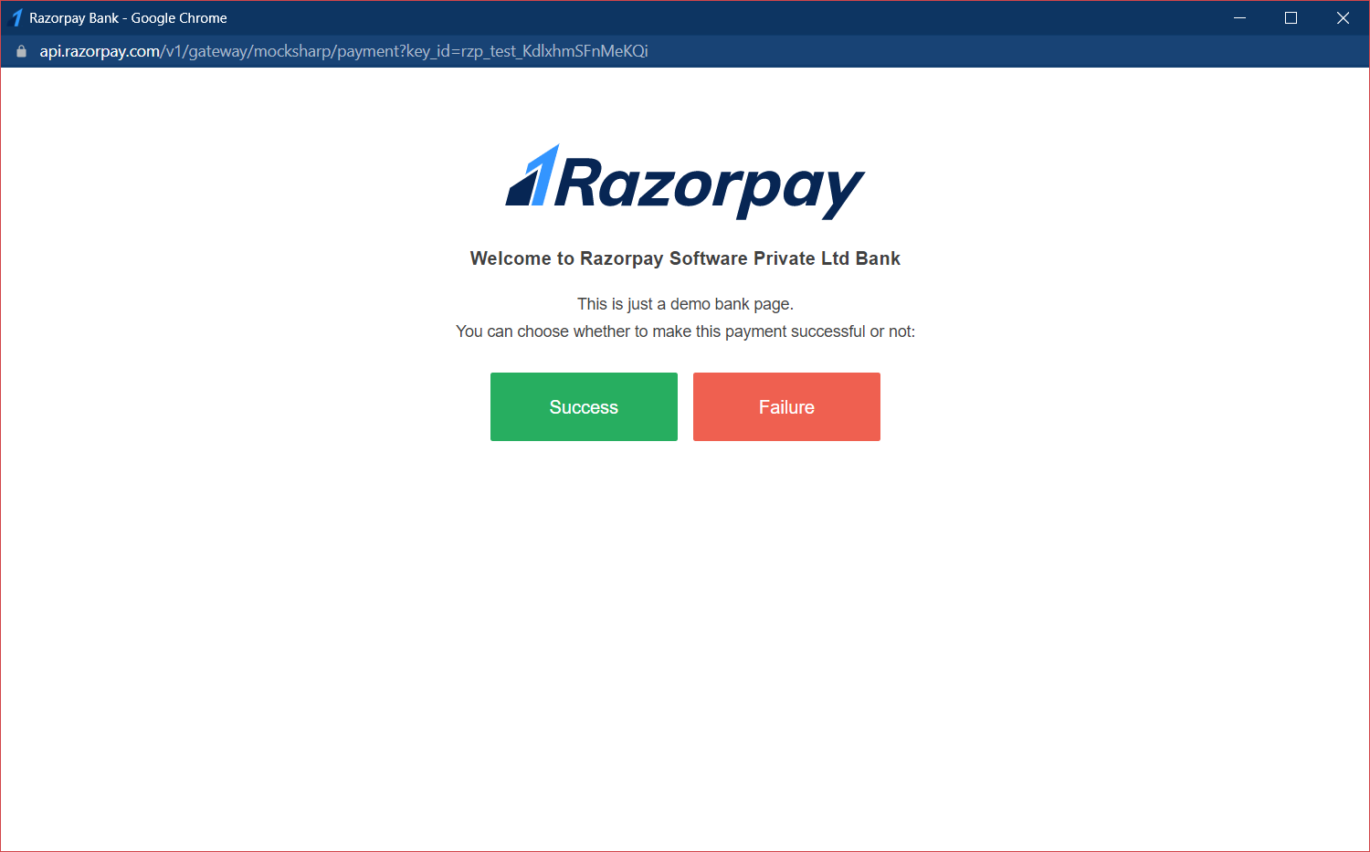

Fig 7.7 Payment

1. **Sell Your Books Page**

This is the sell your books page of the website “BOOMERANG BOOKS” which occurs when the user wants to sell his second hand book to the admin and clicks on the “sell your books” option from the user menu. This page consists of the followings data fields where the user has to upload the book details, book images he wants to sell to the admin and his personal details and make a request as shown in fig 7.8

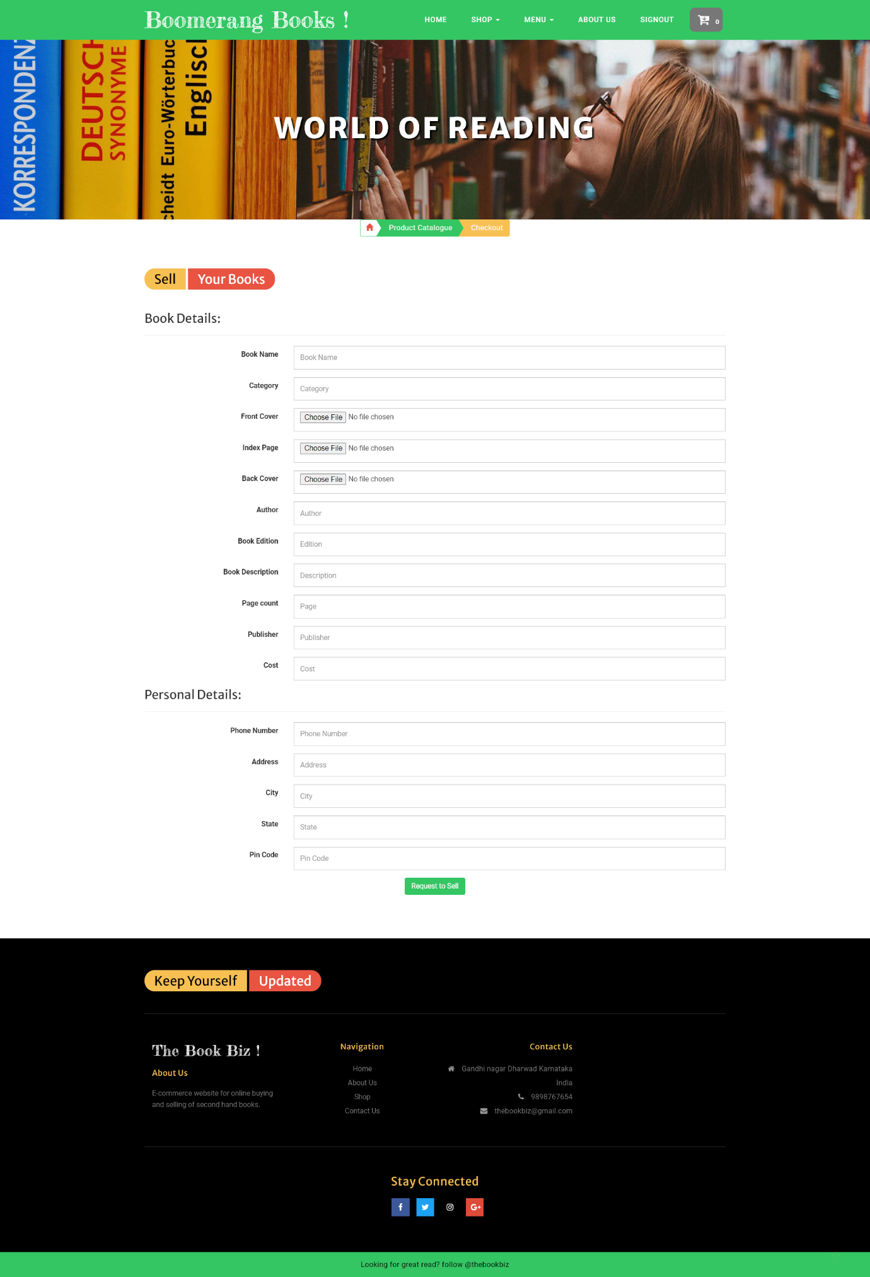

Fig 7.8 Sell your books page

1. **View Order Page**

This is the books page of the website “BOOMERANG BOOKS” where the user can view the requested books and the book details. He can also view the book status whether the book requests are accepted or kept pending by the admin as shown in fig 7.9

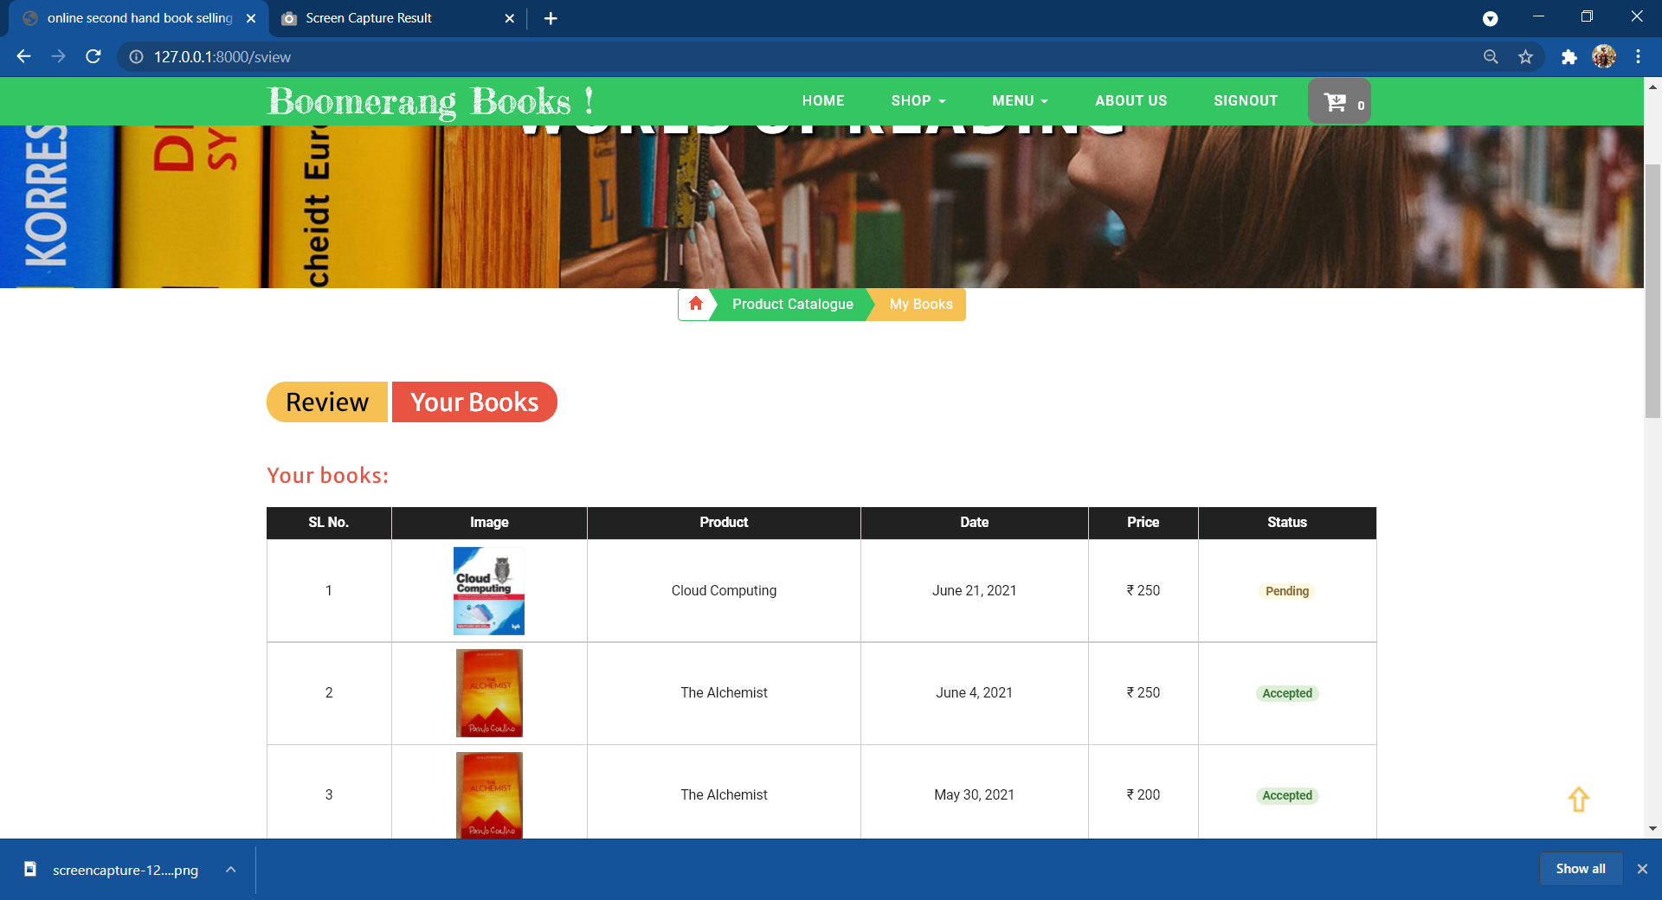

Fig 7.9 Order page

**CONCLUSION AND FUTURE SCOPE**

Customer relationship management is focused on the creation and maintenance of

long-term, mutually beneficial relationships with strategically important markets.

Customer relationship management is focused on the creation and maintenance of

long-term, mutually beneficial relationships with strategically important markets.

Customer relationship management is focused on the creation and maintenance of

long-term, mutually beneficial relationships with strategically important markets.

Customer relationship management is focused on the creation and maintenance of

long-term, mutually beneficial relationships with strategically important markets. It is

based on the premise that customers with the highest life-time value potential are

those in whom the company should invest their retention resources. Other customers

might be fired. For others, it may be possible to re-engineer or nurture the

relationship to create new sources of value.

Customer relationship management is focused on the creation and maintenance of

long-term, mutually beneficial relationships with strategically important markets

Software is said to have attained its objective only when it meet all requirements of the user, further the user himself is the person to judge the success of the system. Every attempt has been made to ensure that the system is fully functional & works effectively & efficiently. The system has been tested with simple data to cover all possible options & checked for al outputs. Since the system is flexible & modular, further modifications of this package can be easily incorporated.

* It can be part of android application in future.
* Multiple languages may be implemented for translation purpose.
* Bar code reading facility can be provided.
* Customer’s location may be tracked by the admin in future enhancement.

**Reference/Bibliography**

1. Online second hand book buying and selling system 127.0.0.1:8000
2. BookChor-Buy Old Books,Second Hand Books,New Books <https://www.bookchor.com/>
3. Buy Second Hand Books, Used Books in India <https://www.usedbooksfactory.com/>
4. FULLTEXT01.pdf diva-portal.se <http://www.diva-portal.se/smash/get/diva2:398899/FULLTEXT01.pdf>
5. e-Bookstore :Opening Door to the Garden of Knowledge <http://www.ijsrp.org/research-paper-0617/ijsrp-p6666.pdf>
6. IRJET-Online Book Store by IRJET Journal – Issue <https://www.irjet.net/archives/V7/i5/IRJET-V7I51409.pdf>
7. Ms. Pragati Bagmare1 , Ms. Shraddha Girhepunje2 , Ms. Priya Bisen, “Research Paper on Online Bookshop Management System”, International Journal for Research in Applied Science & Engineering Technology (IJRASET), Volume 5., Issue 4., 2017, page no. 115-117.
8. Fatin Najwa Binti Abdullah Sani1 , Hani Malini binti Majek2 , Umairah binti Ahmad Khairudin3 , Abdul Rahman bin Ahmad Dahlan4, “e-Bookstore: Opening Door to the Garden of Knowledge”, International Journal of Scientific and Research Publications, Volume 7, Issue 6, June 2017 ,page no. 2250-3153